PRESS RELEASE
For Immediate Release
South Dakota Canvassing Group
Media Contact: SDcanvassing.com / sdcanvass@protonmail.com
Vicky Buhr 605-360-4441

South Dakota Canvassing Group will be holding a press conference Tuesday, September 20th, 2022 at 11:00 AM on the steps of the Old Courthouse Museum located at 200 W 6th Street, Sioux Falls, South Dakota to disclose findings from canvassing and evidence of possible criminal activity.

South Dakota Canvassing Group has hundreds of signed affidavits by registered voters of ghost votes, lost votes, and stolen votes. We will provide some of this evidence to the press. We will also be disclosing more evidence of anomalies from voter roll analysis at the press conference. We will also be updating the press as to what a cast vote record is and its importance to voters.

Attached is an example of what will be disclosed. Please respond to our media contact if you will be in attendance.

Exhibit 1
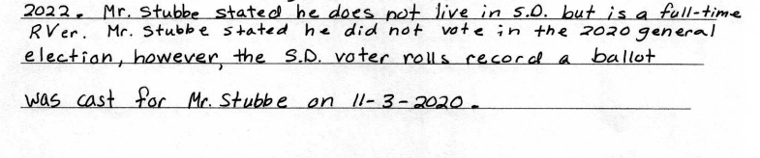
Exhibit 2
